Для разработки авторизации требуется строка подключения к базе данных:

Data Source=KRISTINA\SQLEXPRESS;Initial Catalog=PP_Kiselev;Integrated Security=True;Encrypt=False

Код C#:

using System;

using System.Collections.Generic;

using System.ComponentModel;

using System.Data;

using System.Data.SqlClient;

using System.Drawing;

using System.Linq;

using System.Text;

using System.Threading.Tasks;

using System.Windows.Forms;

namespace PP_KISELEV

{

public partial class Avtorizaciya : Form

{

public Avtorizaciya()

{

InitializeComponent();

}

private void b_2_Click(object sender, EventArgs e)

{

this.Close();

}

private void b_1_Click(object sender, EventArgs e)

{

SqlConnection sqlcon = new SqlConnection(@"Data Source=KRISTINA\SQLEXPRESS;Initial Catalog=PP_Kiselev;Integrated Security=True;Encrypt=False");

string query = "Select * from Polzovateli Where [Login] = '" + tb_1.Text.Trim() + "' and [Parol] = '" + tb_2.Text.Trim() + "'";

SqlDataAdapter sda = new SqlDataAdapter(query, sqlcon);

DataTable dttbl = new DataTable();

sda.Fill(dttbl);

if (dttbl.Rows.Count == 1)

{

string userRole = dttbl.Rows[0]["Roli"].ToString();

if (userRole == "Admin")

{

Menu_Administratora gn = new Menu_Administratora();

this.Hide();

gn.ShowDialog();

this.Show();

}

else if (userRole == "User")

{

Menu_Polzovatelya gn = new Menu_Polzovatelya();

this.Hide();

gn.ShowDialog();

this.Show();

}

}

else

{

MessageBox.Show("Не верно введен логин или пароль");

tb_1.Clear();

tb_2.Clear();

}

}

}

}

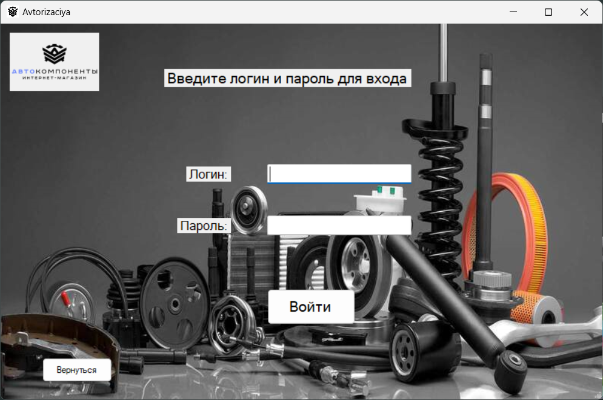

Рис 1. Окно Авторизации

Данные для входа:

|  |  |  |
| --- | --- | --- |
| Login | Parol | Roli |
| ivan@mail.ru | IvPe#2023 | User |
| maria@gmail.com | MaSi@2023 | User |
| alex@yandex.ru | AlKo!2023 | User |
| olga@mail.com | OlIv$2023 | User |
| dmitry@inbox.ru | DmSm%2023 | User |
| ekaterina@mail.ru | EkVa^2023 | User |
| artem@gmail.com | ArFe&2023 | User |
| anna@yandex.ru | AnMo*2023 | User |
| pavel@inbox.ru | PaNi(2023) | User |
| tatyana@mail.com | TaBe=2023 | User |
| sergey@gmail.com | SeKo+2023 | User |
| yulia@yandex.ru | YuAn-2023 | User |
| mikhail@mail.ru | MiSo_2023 | User |
| nadezhda@inbox.ru | NaPa~2023 | User |
| andrey@gmail.com | AnLe>2023 | User |
| lyudmila@yandex.ru | LyVi<2023 | User |
| viktor@mail.ru | ViKr|2023 | User |
| elena@inbox.ru | ElGr:2023 | User |
| galina@gmail.com | GaTi;2023 | User |
| konstantin@yandex.ru | KoSa"2023 | User |
| oksana@mail.ru | OkRo?2023 | User |
| igor@inbox.ru | IgMeї2023 | User |
| zoya@gmail.com | ZoKuЎ2023 | User |
| stanislav@yandex.ru | StOr«2023» | User |
| valentina@mail.ru | VaSe§2023 | User |
| anna@store.com | AnKu$2020 | Admin |
| sergey@store.com | SeVo!2021 | Admin |
| elena@store.com | ElBe#2019 | Admin |
| pavel@store.com | PaGr%2022 | Admin |
| natalia@store.com | NaOr&2023 | Admin |
| dmitry@store.com | DmSo*2019 | Admin |
| olga@store.com | OlMe(2020) | Admin |
| artem@store.com | ArIv=2021 | Admin |
| lyudmila@store.com | LyPe+2023 | Admin |
| igor@store.com | IgKo-2020 | Admin |
| tamara@store.com | TaFe_2022 | Admin |
| vladimir@store.com | VlSt~2021 | Admin |
| svetlana@store.com | SvKr>2023 | Admin |
| georgiy@store.com | GePa<2019 | Admin |
| alina@store.com | AlMa|2020 | Admin |
| roman@store.com | RoBo:2022 | Admin |
| valeriya@store.com | VaTi;2021 | Admin |
| kirill@store.com | KiMo"2023 | Admin |
| evgeniya@store.com | EvAl?2020 | Admin |
| stanislav@store.com | StGuї2019 | Admin |
| marina@store.com | MaSeЎ2022 | Admin |
| andrey@store.com | AnFr«2021» | Admin |
| vera@store.com | VeKo§2023 | Admin |
| gleb@store.com | GlNo=2020 | Admin |
| larisa@store.com | LaVo%2022 | Admin |